Generate content dynamically with Lambda@Edge
Pre-requisite
As a pre-requisite to this lab, you must first complete the “Accelerate your content using CloudFront” lab, as we will be using the distribution you have created there to associate our lambda function.

Introduction
In this lab, you will use Lambda@Edge to dynamically generate the page created in Lab 1. Rather than a simple dump of the request headers, we will output the values in an HTML table. You will learn how to create Lamdba@Edge permissions, deploy functional Lambda@Edge code, and test it. Finally, you will be able to view function logs, metrics, and troubleshoot your code.
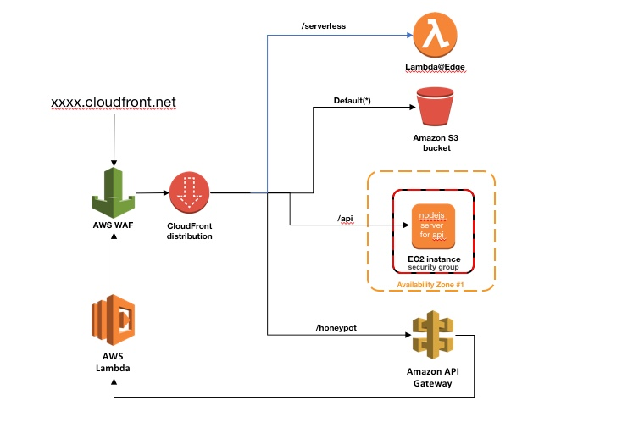

Create a new Cache Behavior
In this section you will create a new cache behavior in the CloudFront distribution that you created in Lab 1. You will use this cache behavior to associate the Lambda@Edge function that you will be writing.

1) Go to the CloudFront console and select the distribution you created in Lab 1. Go to the cache behaviors tab and click “Create Behavior”.
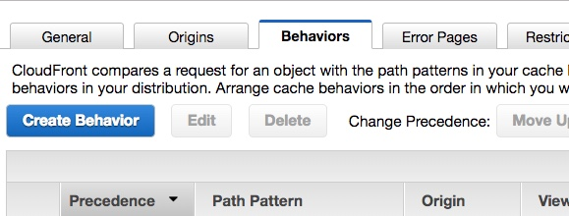

2) Configure your new cache behavior with the following settings and leave the remaining to settings to the default values and click “Create”:
- Path : “/serverless”
- Origin: <Select the EC2 origin created in Lab 1>
- Cache Based on Selected Request Headers: “All”
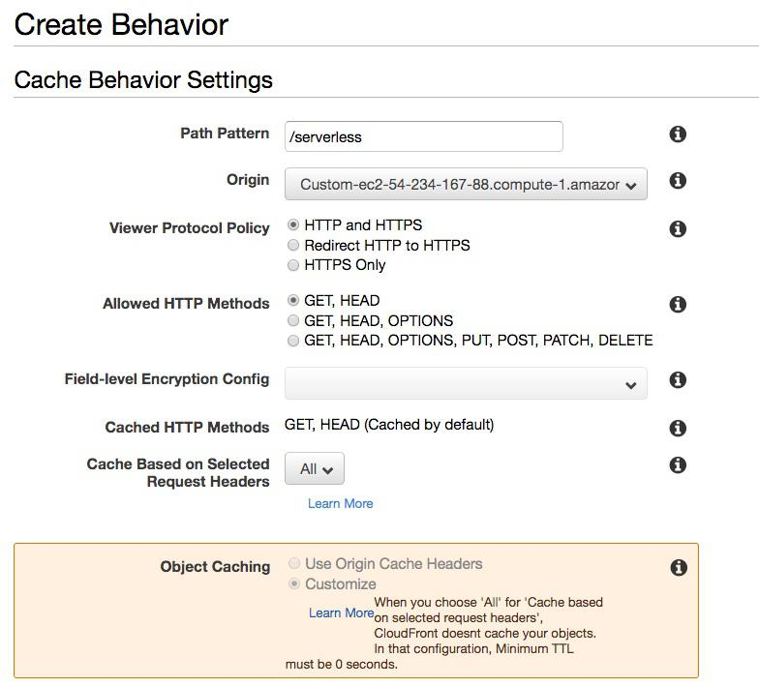

Create a Lambda@Edge function
1) Go to the AWS Console and make sure you are in the US-EAST-1 N. Virginia region.
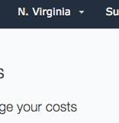

2) Go to the Lambda console and select “Create function”. Then select “Author from scratch” and configure the following then click “Create function”.
- Name: “LambdaEdgeImmersionDayLabFunction”
- Runtime: “Node.js 8.10”
- Role: “Create new role from template(s)”
- Role name: “lambda_edge_execution_role”
- Policy templates: “Basic Lambda@Edge permissions (for CloudFront trigger)”
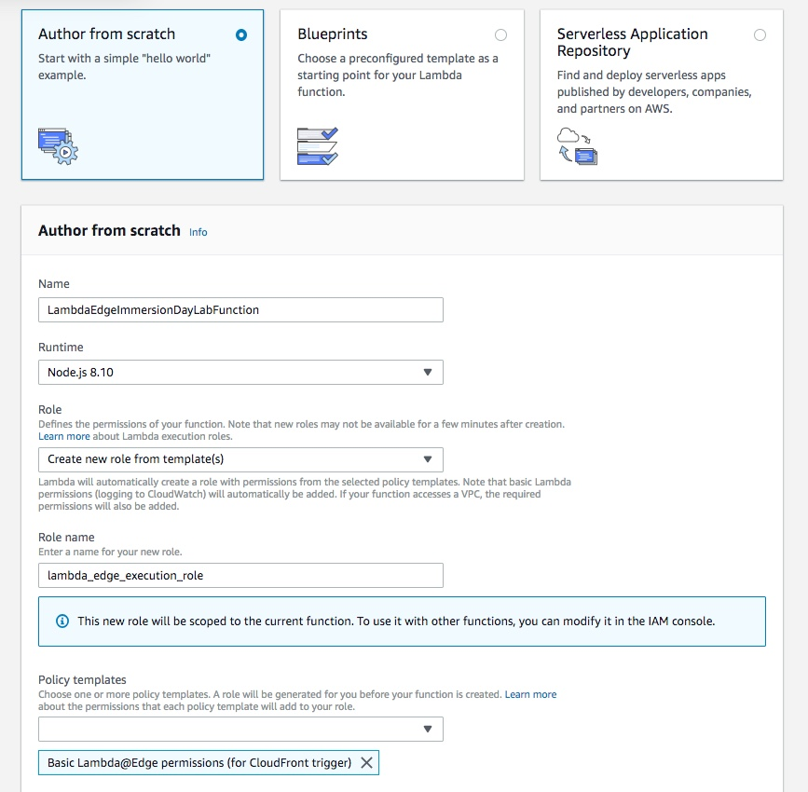

You have now created a new IAM role that will be used to allow CloudFront to invoke lambda and write logs to CloudWatch.

3) Configure a new test event that can be used to test your function locally from the Lambda console. Select from the drop down “Configure Test Events”.
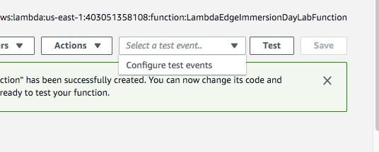

4) Configure the following:
- select “Create new test event”
- Event Name : “TestEvent”
- Replace the Hello World JSON with the following:
{
"Records": [
{
"cf": {
"config": {
"distributionDomainName": "d123.cloudfront.net",
"distributionId": "EDFDVBD6EXAMPLE",
"eventType": "viewer-request",
"requestId": "MRVMF7KydIvxMWfJIglgwHQwZsbG2IhRJ07sn9AkKUFSHS9EXAMPLE=="
},
"request": {
"clientIp": "2001:0db8:85a3:0:0:8a2e:0370:7334",
"querystring": "size=large",
"uri": "/picture.jpg",
"method": "GET",
"headers": {
"host": [
{
"key": "Host",
"value": "d111111abcdef8.cloudfront.net"
}
],
"user-agent": [
{
"key": "User-Agent",
"value": "curl/7.51.0"
}
]
},
"origin": {
"custom": {
"customHeaders": {
"my-origin-custom-header": [
{
"key": "My-Origin-Custom-Header",
"value": "Test"
}
]
},
"domainName": "example.com",
"keepaliveTimeout": 5,
"path": "/custom_path",
"port": 443,
"protocol": "https",
"readTimeout": 5,
"sslProtocols": [
"TLSv1",
"TLSv1.1"
]
},
"s3": {
"authMethod": "origin-access-identity",
"customHeaders": {
"my-origin-custom-header": [
{
"key": "My-Origin-Custom-Header",
"value": "Test"
}
]
},
"domainName": "my-bucket.s3.amazonaws.com",
"path": "/s3_path",
"region": "us-east-1"
}
}
}
}
}
]
}
5) Click “Create”
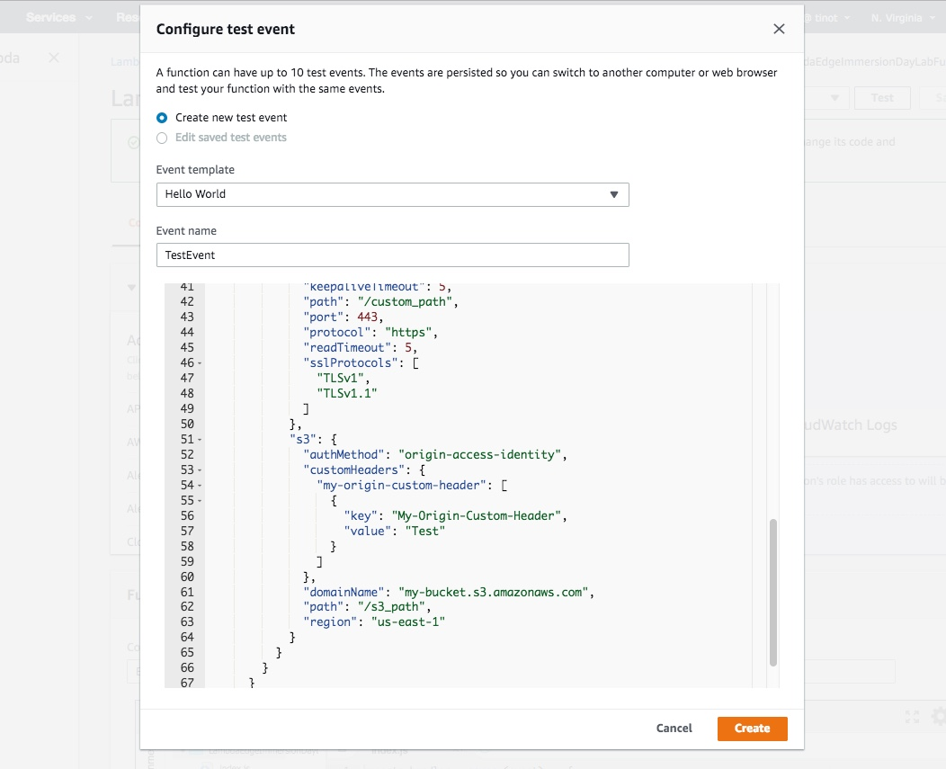

6) Now lets write a function to generate the html produced in Lab 1. Copy and paste the code below into the function code window. Save and Test the function using the TestEvent configured.
exports.handler= (event, context, callback) => {
console.log("Request Event:" + JSON.stringify(event, null, 2));
const requestHeaders = event.Records[0].cf.request.headers;
var htmlContent;
//Insert code to generate the html content content here.
const response = {
status: '200',
statusDescription: 'OK',
headers: {
'cache-control': [{
key: 'Cache-Control',
value: 'max-age=100'
}],
'content-type': [{
key: 'Content-Type',
value: 'text/html'
}],
'content-encoding': [{
key: 'Content-Encoding',
value: 'UTF-8'
}],
},
body: htmlContent,
};
callback(null, response);
}
7) Look at the result of the execution. Notice that the output is a JSON representation of the HTTP 200 response that CloudFront will use to respond to the request. In this case, the response is still missing the body. In the Log output section, notice that the test event that we configured in step 6 logged as the Request Event on the input of the function. This JSON represents attributes of the request received by CloudFront which can be read or modified. In this exercise we will read the headers and return the results in a pretty HTML table.
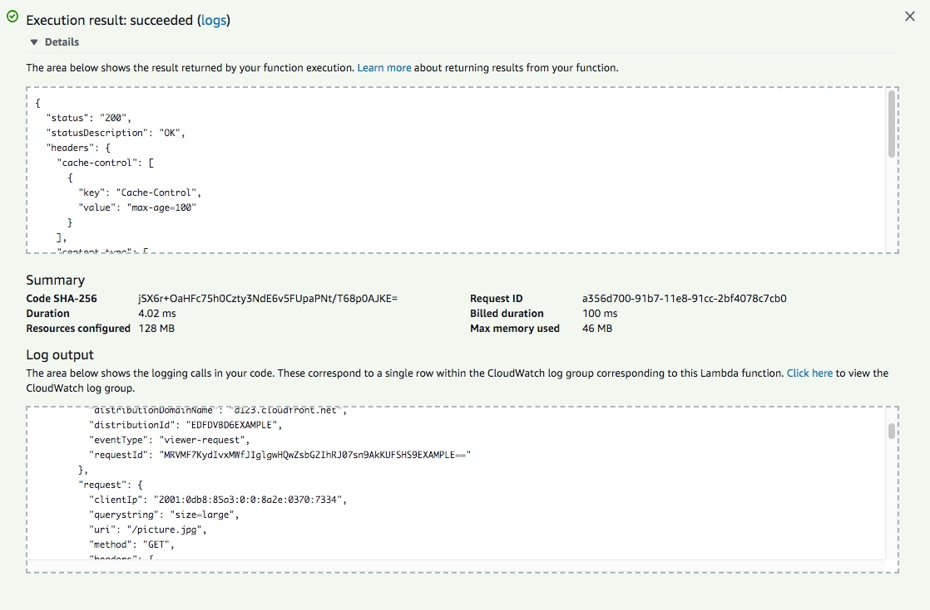

8) Replace the comment with the code needed to generate the html body. You can use console.log to output to troubleshoot your code.

Hidden solution:
exports.handler= (event, context, callback) => {
const requestHeaders = event.Records[0].cf.request.headers;
var str = `<table border="1" width="100%">
<thead>
<tr><td><h1>Header</h2></td><td><h1>Value</h2></td></tr>
</thead>
<tbody>`;
for (var key in requestHeaders) {
if (requestHeaders.hasOwnProperty(key)) {
str += "<tr><td>"+key + "</td><td>" + requestHeaders[key][0].value + "</td></tr>";
}
}
str+= "</tbody></table>";
var htmlContent = `<html lang="en">
<body>
<table border="1" width="100%">
<thead>
<tr><td><h1>Lambda@Edge Lab</h1></td></tr>
</thead>
<tfoot>
<tr><td>Immersion Days - Edge Services - Module 3</td></tr>
</tfoot>
<tbody>
<tr><td>Response sent by API</td></tr>
</tbody>
<tbody>
<tr><td> ` + str + `</td></tr>
</tbody>
</table>
</body>
</html>`;
const response = {
status: '200',
statusDescription: 'OK',
headers: {
'cache-control': [{
key: 'Cache-Control',
value: 'max-age=100'
}],
'content-type': [{
key: 'Content-Type',
value: 'text/html'
}],
'content-encoding': [{
key: 'Content-Encoding',
value: 'UTF-8'
}],
},
body: htmlContent,
};
callback(null, response);
}
9) Once you've completed testing of your function. Publish and deploy the first version of the function. Select the Actions drop down and select publish new version.
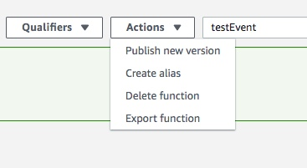

10) Specify a version description then click Publish.
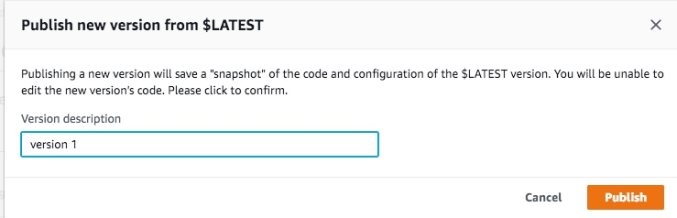

Congratulations you now have a Lambda Function that can be used with CloudFront!

Deploy Lambda@Edge function to CloudFront
In this section we will add CloudFront as a trigger for you Lambda Function.

1) In the same lambda console, you now have Version 1 of the function deployed. Select CloudFront from the list of triggers under the configuration Designer.
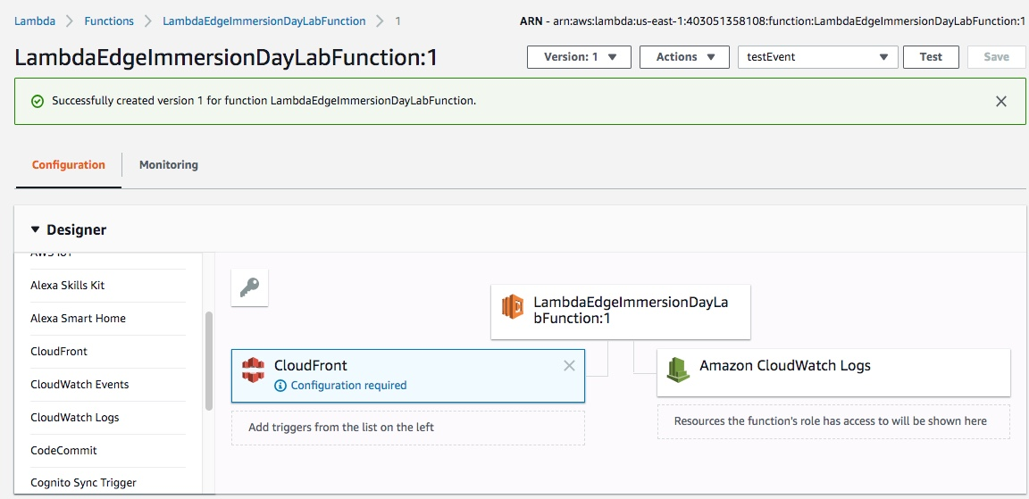

2) Configure the trigger to use the CloudFront Distribution and Cache Behavior created earlier with the following setting, then click Add.
- Distribution: <select the distributionID created from lab 1>
- Cache behavior: “/serverless”
- CloudFront event: Origin request
- Select Enable trigger and replicate (or Confirm deploy to Lambda@Edge)
- Click on Add
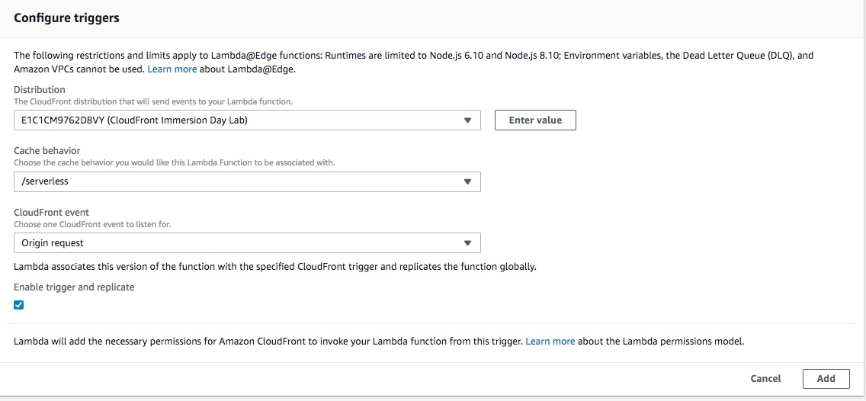

3) Click Save to replicate this function globally and deploy it to your CloudFront distribution! It will take approximately 15 minutes for a full deployment to your CloudFront distribution. In some cases, you maybe able to begin testing it within 5 minutes depending on your location.

4) To view the replica functions to return to the Lambda main console view to list the your functions. Then select the gear icon on the top right to configure your preferences.
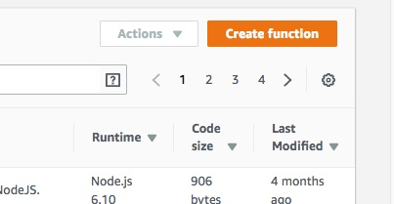

5) Select the check box for “Show replica functions” and click Save.
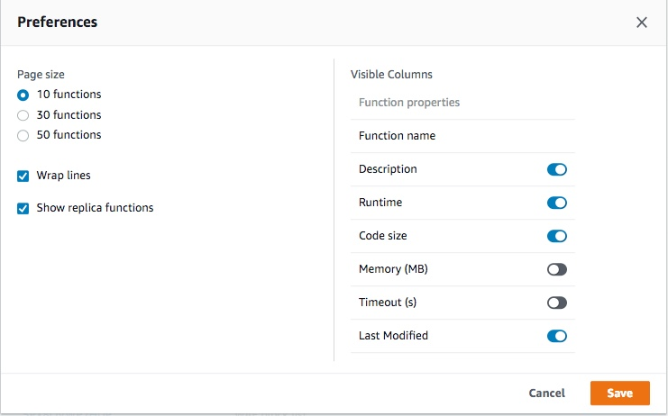

6) Now search for your function in the function list and you will find a Replica function in us-east-1 for the function you created. When you switch to other AWS regions, you will find that there is a replica function in all of the regions where CloudFront has a Regional Edge Cache. These are the functions that will be invoked when your CloudFront distribution executes Lambda@Edge.
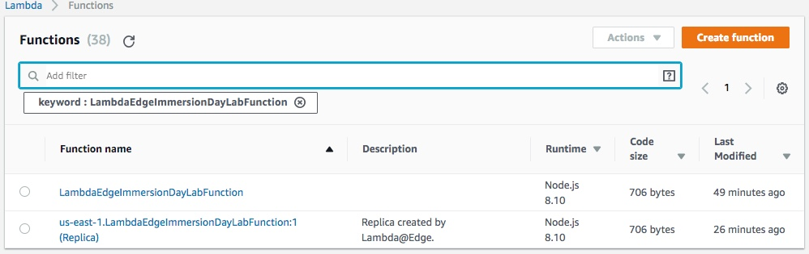

7) Once your cloudfront distribution has completed deploying, test your CloudFront distribution by going to the Distribution on the browser with the serverless path.

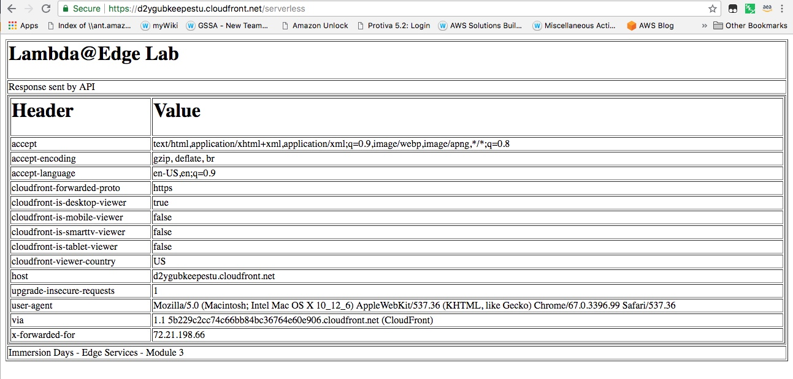

Congratulations! You have successfully deployed your lambda@edge function to dynamically generate a response.

Metrics and Logs
In this section, you will learn where to view Lambda@Edge metrics and CloudWatch logs for your function.

1) To generate some traffic from different geographies, use a free website such as https://www.geoscreenshot.com to send a request to your distribution to hit the serverless path (i.e. https://d123.cloudfront.net/serverless) from different locations. Submit the request several times to generate traffic to CloudFront from different regions.

2) Go to the AWS Lambda console and select an AWS region near one of the geographies that you selected to submit the request from from step 1.

3) Ensure that you have your preferences configured to “show replica functions” as configured in the previous sections. Then select the replica function for that region and view the “Monitoring” tab for that function.

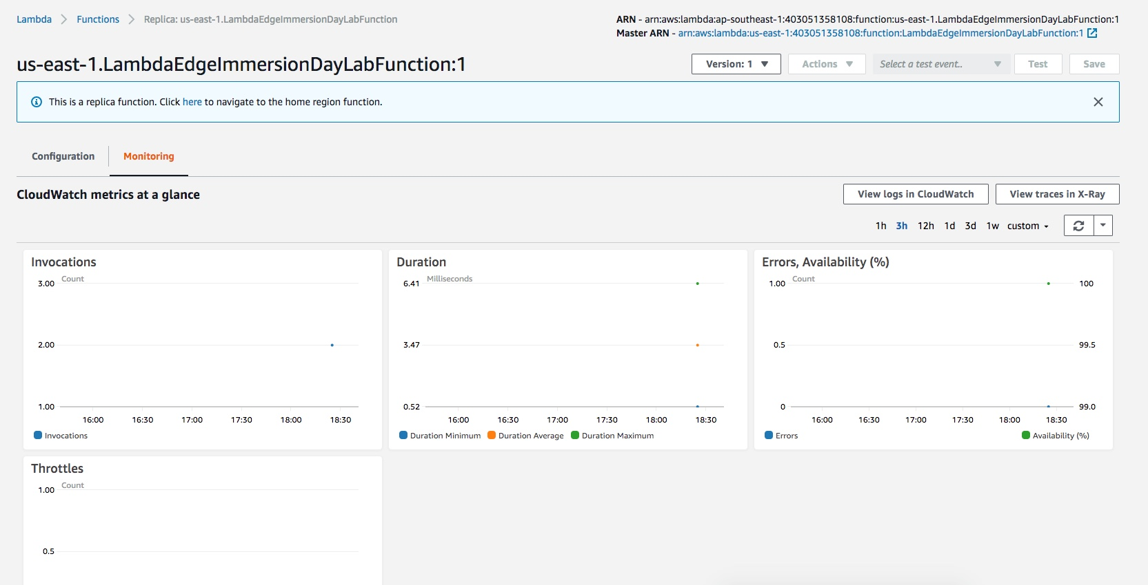

4) To view logs from your function execution, select “View logs in CloudWatch”. Here you can view any logs that are generated from your function invocations. Note, any log lines generated from your code will also appear here.

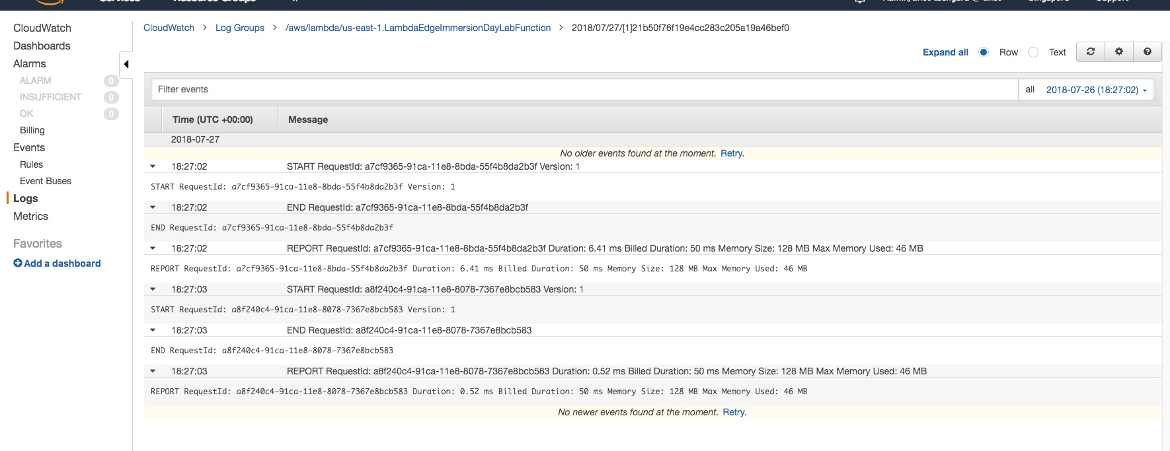

NOTE: Metrics and Logs are not aggregated globally. Switch between different AWS regions to view metrics and logs for function invocations in each regions.

Congratulations! You have completed the lab and now have an understanding of how to configure and deploy Lambda@Edge.

